**FULL SUBTRACTOR**

**EXP.NO: 24**

**AIM:**To design and implement the full subtractor using Logisim simulator.

**PROCEDURE:**

1)  Pick and place the necessary gates.

2)  Insert 3 inputs into the canvas.

3)  Connect the inputs to the XOR gate, AND gate and OR gate.

4)  Insert 2 outputs into the canvas.

5) Make the connections using the connecting wires.

6)      Verify the truth table.

**TRUTH TABLE:**

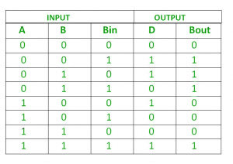  
  
Diff=(A ⊕ B) ⊕ 'Borrowing’  
  
Borrow=A'.B + (A ⊕ B)'  
  
**OUTPUT:**

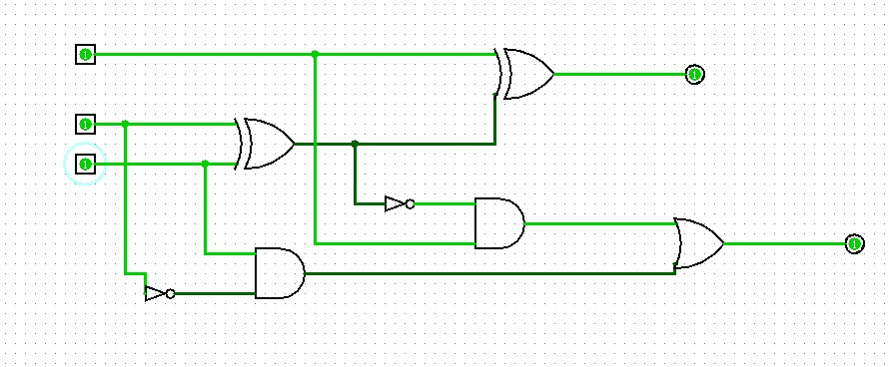  
  
   
  
  
**RESULT:**Thus full subtractor has been designed and implemented successfully using logisim simulator.